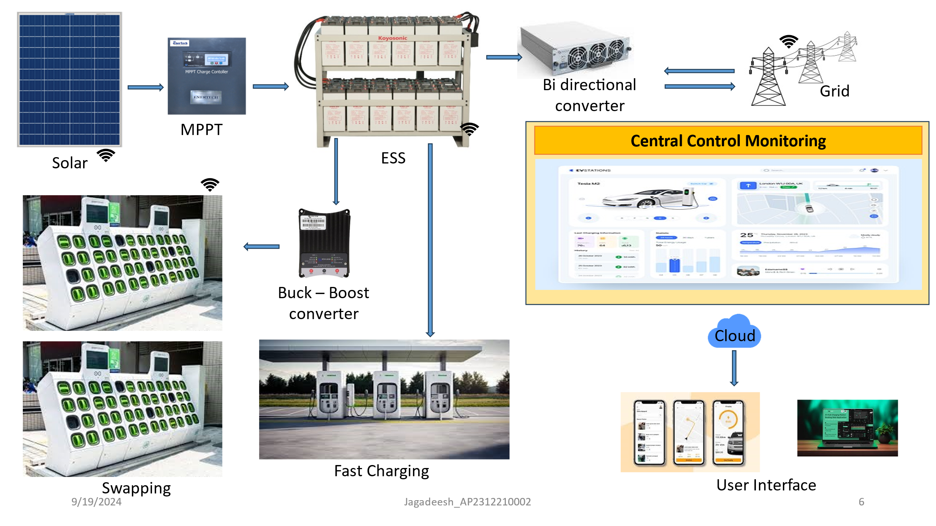
Key Parameters to Monitor Solar Panel:
Solar Panel

Voltage Output: Measures the voltage generated.
Current Output: Monitors the current produced.
Power Generation: Calculates power output (P = V × I).
Temperature: Assesses panel temperature for efficiency.
Light Intensity: Measures sunlight exposure.
Humidity: Tracks environmental conditions.
Fault Detection: Identifies malfunctions or short circuits.

Topology:
Sensor Layer: Sensors connected to a microcontroller for data acquisition.
Microcontroller Layer: Processes data and prepares it for transmission.
Communication Layer: IoT gateway transmits data to the cloud.
Cloud Server Layer: Stores and analyzes data for insights.
User Interface Layer: Web/mobile app for real-time monitoring and alerts.

Required Hardware:
Microcontroller: Arduino Uno or ESP32.
Sensors:
Voltage Sensor (Voltage Divider)
Current Sensor (ACS712)
Temperature Sensor (LM35/DHT11)
Light Intensity Sensor (LDR)
Humidity Sensor (DHT11)
Communication Module: Wi-Fi Module (ESP8266).
Power Supply: Battery or power adapter.
Data Storage/Cloud Platform: AWS or Azure.

IoT-Based Monitoring of Energy Storage Systems (ESS)

Key Parameters to Monitor ESS:

State of Charge (SoC): Available battery capacity as a percentage.
Voltage: Voltage of individual cells or overall battery bank.
Current: Charging and discharging current measurements.
Temperature: Battery temperature for optimal performance.
Battery Health: Assessment of capacity fade and internal resistance.
Charge/Discharge Cycles: Tracking the number of cycles for lifespan prediction.
Energy Input/Output: Measuring energy flow for efficiency calculations.
Fault Detection: Identifying issues like short circuits or imbalances.

Topology:
Sensor Layer: Voltage, current, and temperature sensors connected to batteries.
BMS Layer: Battery Management System processes data and manages operations.
IoT Gateway Layer: Collects data from BMS and transmits it to the cloud.
Cloud Server Layer: Stores data and runs analytics for insights.
User Interface Layer: Web/mobile app for real-time monitoring and alerts.

Required Hardware:
Voltage Sensors: Hall-effect sensors or voltage dividers.
Current Sensors: Hall-effect current sensors.
Temperature Sensors: Thermistors or RTDs.
BMS: For processing data and managing operations.
IoT Gateway: Raspberry Pi or ESP32 for data collection.
Communication Modules: Wi-Fi, Ethernet, or cellular modules.
Power Supply: Battery or external power source.
Cloud Platform: AWS IoT or Azure IoT Hub for data storage.

IoT-Based Monitoring of the Power Grid

Key Parameters to Monitor:

Voltage: Measures voltage levels at various grid points.
Current: Monitors current flow through the grid.
Frequency: Tracks AC power frequency.
Power Factor: Measures the efficiency of power usage.
Harmonics: Monitors harmonic distortion in the grid.
Load: Measures total load on the grid.
Transformer Health: Assesses transformer performance.
Fault Detection: Identifies faults and abnormalities.
Grid Stability: Measures overall stability and reliability.
Renewable Energy Integration: Monitors renewable energy sources in the grid.

Topology:
Sensor Layer: Voltage, current, and power quality sensors installed in the grid.
Data Acquisition Layer: PLC or RTU collects and processes data from sensors.
IoT Gateway Layer: Gateway (e.g., Raspberry Pi) transmits data to the cloud.
Cloud Server Layer: Cloud platform (AWS IoT, Azure IoT) stores and analyzes data.
User Interface Layer: Web/mobile app for real-time monitoring and alerts.

Required Hardware:
Voltage and Current Sensors: PTs and CTs for measurement.
Frequency Sensors: Phase-locked loop (PLL) circuits.
Power Quality Analyzers: For measuring power factor and harmonics.
Data Acquisition System: PLC or RTU for data collection.
IoT Gateway: Raspberry Pi or industrial PC for connectivity.
Communication Modules: Ethernet, cellular, or serial interfaces.
Cloud Platform: AWS IoT or Azure IoT Hub for data storage.

IoT-Based Monitoring of Battery Swapping Stations

Key Parameters to Monitor:
State of Charge (SoC): Available battery capacity as a percentage.
Battery Voltage: Voltage of individual battery packs.
Battery Current: Charging and discharging current measurements.
Battery Temperature: Monitors battery temperature for safety.
Battery Health: Assessment of capacity fade and internal resistance.
Swapping Time: Measures time taken for each battery swap.
Inventory Management: Tracks charged and discharged batteries.
User Identification: Authenticates users during swapping.
Energy Usage: Measures of energy consumed during swaps.
Fault Detection: Identifies issues like short circuits.

Topology:
Sensor Layer: Voltage, current, temperature, RFID/NFC sensors connected to batteries.
Processing Unit Layer: Microcontroller or PLC processes data and manages the swapping process.
IoT Gateway Layer: Gateway (e.g., Raspberry Pi) collects data and transmits it to the cloud.
Cloud Server Layer: Cloud platform (AWS IoT, Azure IoT) stores data and runs analytics.
User Interface Layer: Web/mobile app for real-time monitoring and user notifications.

Required Hardware:
Voltage and Current Sensors: Hall-effect sensors or shunt resistors.
Temperature Sensors: Thermistors or RTDs.
RFID/NFC Sensors: For user identification.
Energy and Time Sensors: To measure energy usage and swapping time.
Processing Unit: Microcontroller or PLC for data processing.
IoT Gateway: Raspberry Pi or industrial PC for connectivity.
Communication Modules: Ethernet, cellular, or serial interfaces.
Cloud Platform: AWS IoT or Azure IoT Hub for analytics.

IoT-Based Monitoring of Fast Charging Stations

Key Parameters to Monitor:
Charging Status: Availability of the charging station (available, in use, out of service).
Charging Power: Measures power delivered to the vehicle (in kW).
Charging Time: Tracks duration of each charging session.
Energy Delivered: Total energy supplied during charging (in kWh).
Charging Efficiency: Monitors efficiency of the charging process.
User Identification: Authenticates users for billing purposes.
Fault Detection: Identifies issues like short circuits or malfunctions.
Utilization Rate: Tracks usage and occupancy of each station.
Station Availability: Real-time availability status of charging stations.
Location Tracking: Monitors the location of each charging station.

Topology:
Sensor Layer: Power, energy, and time sensors connected to charging stations, User identification sensors (RFID/NFC).
Data Acquisition Layer: Charging station controller collects and processes sensor data.
IoT Gateway Layer: Gateway (e.g., Raspberry Pi) transmits data to the cloud.
Cloud Server Layer: Cloud platform (AWS IoT, Azure IoT) stores data and runs analytics.
User Interface Layer: Web/mobile app for real-time monitoring and user notifications.

Required Hardware:
Charging Power Sensors: Hall-effect sensors or energy meters.
Charging Time Sensors: Timers or real-time clocks.
User Identification Sensors: RFID or NFC readers.
Data Acquisition System: PLC or dedicated charging station controller.
IoT Gateway: Raspberry Pi or industrial PC for connectivity.
Communication Modules: Ethernet, cellular, or serial interfaces.
Cloud Platform: AWS IoT or Azure IoT Hub for analytics.

IoT-Based Monitoring with AWS Cloud and User Interface

Key Parameters to Monitor:
Device Status: Real-time status of connected IoT devices.
Data Ingestion Rate: Rate at which data is collected from devices.
Latency: Time taken for data to travel from devices to the cloud.
Data Quality Metrics: Measures accuracy and completeness of incoming data.
User Interactions: Tracks user engagement with the interface.
Alerts and Notifications: Monitors system alerts based on predefined conditions.
Resource Utilization: Tracks usage of cloud resources (CPU, memory).
Historical Data Trends: Analyzes trends over time for better decision-making.

Topology:
Device Layer: IoT devices equipped with sensors and communication modules.
Data Ingestion Layer: AWS IoT Core collects data from devices via MQTT or HTTPS protocols.
Processing Layer: AWS Lambda functions process incoming data and perform real-time analytics.
Storage Layer: Amazon DynamoDB or Amazon S3 stores processed data for further analysis.
Analytics Layer: AWS IoT Analytics or Amazon QuickSight for advanced analytics and visualization.
User Interface Layer: Custom web or mobile applications provide real-time dashboards and user interactions.

Required Hardware:
IoT Devices: Microcontrollers (e.g., Raspberry Pi, Arduino) with sensors.
Communication Modules: Wi-Fi, Ethernet, or cellular modules for connectivity.
Cloud Services: AWS IoT Core for device management and data ingestion.
Data Processing Tools: AWS Lambda for real-time data processing.
Data Storage Solutions: Amazon DynamoDB or Amazon S3 for data storage.
User Interface Development Tools: AWS Amplify or custom frameworks (React, Angular).

